1-Concrete Classes

📌 Definition:
# Source: AI Source: Provided by: [Data Path: Persons Table -> ID Column: 1, Name_En Column: Motasem Essam] -> From: [Chatgpt (GPT‑5 Mini)] on [12/9/2025]
A concrete class is a class that is fully implemented and can be instantiated, meaning you can create objects from it.

🧠 Simple idea:
# Source: AI Source: Provided by: [Data Path: Persons Table -> ID Column: 1, Name_En Column: Motasem Essam] -> From: [Chatgpt (GPT‑5 Mini)] on [12/9/2025]
Concrete Class = “Complete class you can use directly” ✅

🔍 Key characteristics:
# Source: AI Source: Provided by: [Data Path: Persons Table -> ID Column: 1, Name_En Column: Motasem Essam] -> From: [Chatgpt (GPT‑5 Mini)] on [12/9/2025]
- ✅ Can create objects (instantiable)
- 📌 Contains fully implemented methods
- ❌ Does not have abstract methods (or must implement them if inherited)
- 🔗 Can inherit from abstract classes or other classes
- 🧩 Represents real, usable entities

📌 Example (Java):
# Source: AI Source: Provided by: [Data Path: Persons Table -> ID Column: 1, Name_En Column: Motasem Essam] -> From: [Chatgpt (GPT‑5 Mini)] on [12/9/2025]
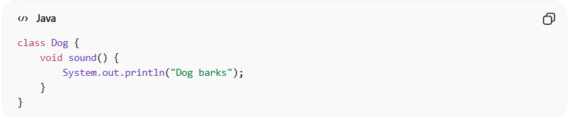
class Dog {
void sound() {
System.out.println("Dog barks");
}
}

Usage:
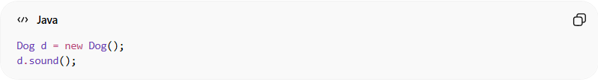
Dog d = new Dog();
d.sound();
👉 You can directly create and use the object.

📌 Example with abstract class:
# Source: AI Source: Provided by: [Data Path: Persons Table -> ID Column: 1, Name_En Column: Motasem Essam] -> From: [Chatgpt (GPT‑5 Mini)] on [12/9/2025]
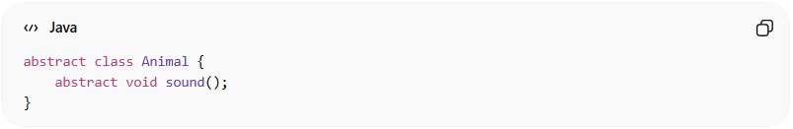
abstract class Animal {
abstract void sound();
}
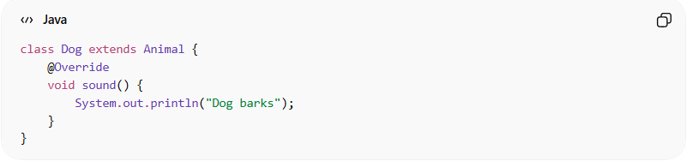
class Dog extends Animal {
@Override
void sound() {
System.out.println("Dog barks");
}
}
👉 Dog is a concrete class because it implements all abstract methods.

🆚 Concrete Class vs Abstract Class:
# Source: AI Source: Provided by: [Data Path: Persons Table -> ID Column: 1, Name_En Column: Motasem Essam] -> From: [Chatgpt (GPT‑5 Mini)] on [12/9/2025]
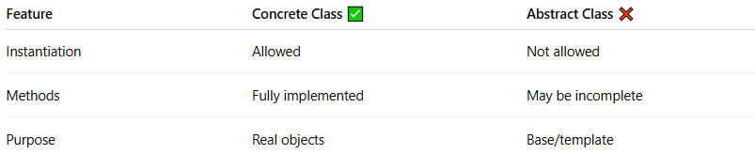
Feature | Concrete Class ✅ | Abstract Class ❌
Instantiation | Allowed | Not allowed
Methods | Fully implemented | May be incomplete
Purpose | Real objects | Base/template

🎯 Why concrete classes are important:
# Source: AI Source: Provided by: [Data Path: Persons Table -> ID Column: 1, Name_En Column: Motasem Essam] -> From: [Chatgpt (GPT‑5 Mini)] on [12/9/2025]
- 🧩 Represent actual objects in the system
- ⚙️ Provide full functionality
- 🔄 Used directly in programs
- 🧠 Complete the abstraction process

🎯 Summary:
# Source: AI Source: Provided by: [Data Path: Persons Table -> ID Column: 1, Name_En Column: Motasem Essam] -> From: [Chatgpt (GPT‑5 Mini)] on [12/9/2025]
Concrete classes are fully implemented classes that can be instantiated and used to create real objects in a program.

2-Concrete methods

📌 Definition:
# Source: AI Source: Provided by: [Data Path: Persons Table -> ID Column: 1, Name_En Column: Motasem Essam] -> From: [Chatgpt (GPT‑5 Mini)] on [12/9/2025]
A concrete method is a method that has a complete implementation (method body) and defines how a task is performed.

🧠 Simple idea:
# Source: AI Source: Provided by: [Data Path: Persons Table -> ID Column: 1, Name_En Column: Motasem Essam] -> From: [Chatgpt (GPT‑5 Mini)] on [12/9/2025]
Concrete Method = “Fully implemented method” ✅

🔍 Key characteristics:
# Source: AI Source: Provided by: [Data Path: Persons Table -> ID Column: 1, Name_En Column: Motasem Essam] -> From: [Chatgpt (GPT‑5 Mini)] on [12/9/2025]
- ✅ Has a method body (implementation)
- ⚙️ Defines actual behavior
- 🔄 Can be called directly
- 🧩 Can exist in both concrete and abstract classes
- 🔁 Can be overridden in subclasses

📌 Example (Java):
# Source: AI Source: Provided by: [Data Path: Persons Table -> ID Column: 1, Name_En Column: Motasem Essam] -> From: [Chatgpt (GPT‑5 Mini)] on [12/9/2025]
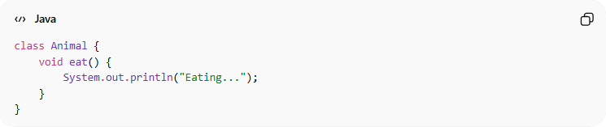
class Animal {
void eat() {
System.out.println("Eating...");
}
}

Usage:
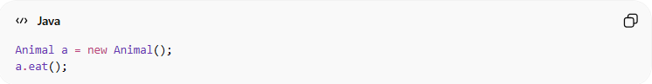
Animal a = new Animal();
a.eat();
👉 The method eat():
- Has full implementation
- Can be executed directly

📌 Example with inheritance:
# Source: AI Source: Provided by: [Data Path: Persons Table -> ID Column: 1, Name_En Column: Motasem Essam] -> From: [Chatgpt (GPT‑5 Mini)] on [12/9/2025]
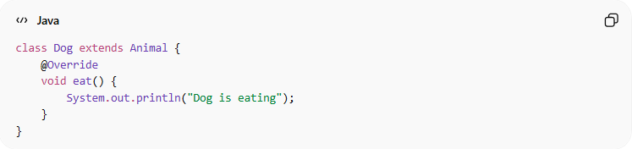
class Dog extends Animal {
@Override
void eat() {
System.out.println("Dog is eating");
}
}
👉 Concrete methods can be overridden to change behavior.

🆚 Concrete Method vs Abstract Method:
# Source: AI Source: Provided by: [Data Path: Persons Table -> ID Column: 1, Name_En Column: Motasem Essam] -> From: [Chatgpt (GPT‑5 Mini)] on [12/9/2025]
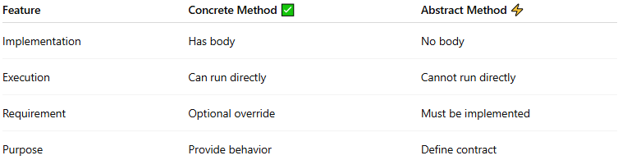
Feature | Concrete Method ✅ | Abstract Method ⚡
Implementation | Has body | No body
Execution | Can run directly | Cannot run directly
Requirement | Optional override | Must be implemented
Purpose | Provide behavior | Define contract

🎯 Why concrete methods are important:
# Source: AI Source: Provided by: [Data Path: Persons Table -> ID Column: 1, Name_En Column: Motasem Essam] -> From: [Chatgpt (GPT‑5 Mini)] on [12/9/2025]
- ⚙️ Provide actual functionality
- 🧩 Make classes usable
- 🔄 Allow customization via overriding
- 🧠 Complete the behavior defined by abstract methods

🎯 Summary:
# Source: AI Source: Provided by: [Data Path: Persons Table -> ID Column: 1, Name_En Column: Motasem Essam] -> From: [Chatgpt (GPT‑5 Mini)] on [12/9/2025]
Concrete methods are fully implemented methods that define actual behavior and can be directly executed in a program.

